Sentiment Analysis Using Python

Introduction
In today’s digital age, platforms like Twitter, Goodreads, and Amazon overflow with people’s opinions, making it crucial for organizations to extract insights from this massive volume of data. Sentiment Analysis in Python offers a powerful solution to this challenge. This technique, a subset of Natural Language Processing (NLP), involves classifying texts into sentiments such as positive, negative, or neutral. By employing various Python libraries and models, analysts can automate this process efficiently. Let’s delve into how to perform sentiment analysis in Python and explore some examples of its application.So , Basically we share information regarding this in the article about sentiment analysis using python and how to do sentiment analysis in pyhton.

What is Sentiment Analysis?
Sentiment Analysis is a use case of Natural Language Processing (NLP) and comes under the category of text classification. To put it simply, Sentiment Analysis involves classifying a text into various sentiments, such as positive or negative, Happy, Sad or Neutral, etc. Thus, the ultimate goal of sentiment analysis is to decipher the underlying mood, emotion, or sentiment of a text. This is also referred to as Opinion Mining.

What is Sentiment Analysis?
Sentiment Analysis is a use case of Natural Language Processing (NLP) and comes under the category of text classification. To put it simply, Sentiment Analysis involves classifying a text into various sentiments, such as positive or negative, Happy, Sad or Neutral, etc. Thus, the ultimate goal of sentiment analysis is to decipher the underlying mood, emotion, or sentiment of a text. This is also referred to as Opinion Mining.

How Does Sentiment Analysis Work?
Sentiment analysis in Python typically works by employing natural language processing (NLP) techniques to analyze and understand the sentiment expressed in text. The process involves several steps:
- Text Preprocessing: The text cleaning process involves removing irrelevant information, such as special characters, punctuation, and stopwords, from the text data.
- Tokenization: The text is divided into individual words or tokens to facilitate analysis.
- Feature Extraction: The text extraction process involves extracting relevant features from the text, such as words, n-grams, or even parts of speech.
- Sentiment Classification: Machine learning algorithms or pre-trained models are used to classify the sentiment of each text instance. Researchers achieve this through supervised learning, where they train models on labeled data, or through pre-trained models that have learned sentiment patterns from large datasets.
- Post-processing: The sentiment analysis results may undergo additional processing, such as aggregating sentiment scores or applying threshold rules to classify sentiments as positive, negative, or neutral.
- Evaluation: Researchers assess the performance of the sentiment analysis model using evaluation metrics, such as accuracy, precision, recall, or F1 score.

Types of Sentiment Analysis
Various types of sentiment analysis can be performed, depending on the specific focus and objective of the analysis. Some common types include:
- Document-Level Sentiment Analysis: This type of analysis determines the overall sentiment expressed in a document, such as a review or an article. It aims to classify the entire text as positive, negative, or neutral.
- Sentence-Level Sentiment Analysis: Here, the sentiment of each sentence within a document is analyzed. This type provides a more granular understanding of the sentiment expressed in different text parts.
- Aspect-Based Sentiment Analysis: This approach focuses on identifying and extracting the sentiment associated with specific aspects or entities mentioned in the text. For example, in a product review, the sentiment towards different features of the product (e.g., performance, design, usability) can be analyzed separately.
- Entity-Level Sentiment Analysis: This type of analysis identifies the sentiment expressed towards specific entities or targets mentioned in the text, such as people, companies, or products. It helps understand the sentiment associated with different entities within the same document.
- Comparative Sentiment Analysis: This approach involves comparing the sentiment between different entities or aspects mentioned in the text. It aims to identify the relative sentiment or preferences expressed towards various entities or features.

Gaining Insights and Making Decisions with Sentiment Analysis
Sentiment analysis is a valuable tool for organizations to understand customer sentiment and make informed decisions. For example, a perfume company selling online can use sentiment analysis to determine popular fragrances and offer discounts on unpopular ones. By analyzing customer reviews, the company can identify popular fragrances and make informed decisions. However, due to the vast number of fragrances available, it can be challenging to analyze all of them in one lifetime.
You simply gather all the reviews in one place and apply sentiment analysis to it. The following is a schematic representation of sentiment analysis on the reviews of three fragrances of perfumes — Lavender, Rose, and Lemon. (Please note that these reviews might have incorrect spellings, grammar, and punctuations as it is in the real-world scenarios)
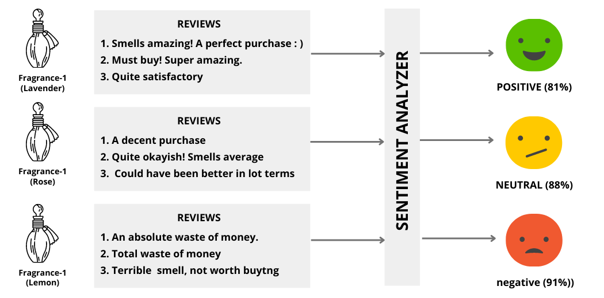

From these results, we can clearly see that:
- Fragrance-1 (Lavender) has highly positive reviews by the customers which indicates your company can escalate its prices given its popularity.
- Fragrance-2 (Rose) happens to have a neutral outlook amongst the customer which means your company should not change its pricing.
- Fragrance-3 (Lemon) has an overall negative sentiment associated with it — thus, your company should consider offering a discount on it to balance the scales.
This was just a simple example of how sentiment analysis can help you gain insights into your products/services and help your organization make decisions.

Sentiment Analysis Use Cases
We just saw how sentiment analysis can empower organizations with insights that can help them make data-driven decisions. Now, let’s peep into some more use cases of sentiment analysis:
- Social Media Monitoring for Brand Management: Brands can use sentiment analysis to gauge their Brand’s public outlook. For example, a company can gather all Tweets with the company’s mention or tag and perform sentiment analysis to learn the company’s public outlook.
- Product/Service Analysis: Brands/Organizations can perform sentiment analysis on customer reviews to see how well a product or service is doing in the market and make future decisions accordingly.
- Stock Price Prediction: Predicting whether the stocks of a company will go up or down is crucial for investors. One can determine the same by performing sentiment analysis on News Headlines of articles containing the company’s name. If the news headlines pertaining to a particular organization happen to have a positive sentiment — its stock prices should go up and vice-versa.

Ways to Perform Sentiment Analysis in Python
Python is one of the most powerful tools when it comes to performing data science tasks — it offers a multitude of ways to perform sentiment analysis in Python. The most popular ones are enlisted here:
- Using Text Blob
- Using Vader
- Using Bag of Words Vectorization-based Models
- Using LSTM-based Models
- Using Transformer-based Models
Let’s dive deep into them one by one.
Note: For the purpose of demonstrations of methods 3 & 4 (Using Bag of Words Vectorization-based Models and Using LSTM-based Models) sentiment analysis has been used. It comprises more than 5000 text labelled as positive, negative or neutral. The dataset lies under the Creative Commons license.

Using Text Blob
Text Blob is a Python library for Natural Language Processing. Using Text Blob for sentiment analysis is quite simple. It takes text as an input and can return polarity and subjectivity as outputs.
- Polarity determines the sentiment of the text. Its values lie in [-1,1] where -1 denotes a highly negative sentiment and 1 denotes a highly positive sentiment.
- Subjectivity determines whether a text input is factual information or a personal opinion. Its value lies between [0,1] where a value closer to 0 denotes a piece of factual information and a value closer to 1 denotes a personal opinion.
Here is Steps to perform sentiment analysis using python and putting sentiment analysis code in python.

Step1: Installation
pip install textblob

Step2: Importing Text Blob
from textblob import TextBlob

Step3: Code Implementation for Sentiment Analysis Using Text Blob
Writing code for sentiment analysis using TextBlob is fairly simple. Just import the TextBlob object and pass the text to be analyzed with appropriate attributes as follows:
from textblob import TextBlob

text_1 = "The movie was so awesome."
text_2 = "The food here tastes terrible."

#Determining the Polarity
p_1 = TextBlob(text_1).sentiment.polarity
p_2 = TextBlob(text_2).sentiment.polarity

#Determining the Subjectivity
s_1 = TextBlob(text_1).sentiment.subjectivity
s_2 = TextBlob(text_2).sentiment.subjectivity

print("Polarity of Text 1 is", p_1)
print("Polarity of Text 2 is", p_2)
print("Subjectivity of Text 1 is", s_1)
print("Subjectivity of Text 2 is", s_2)
Output
Polarity of Text 1 is 1.0
Polarity of Text 2 is -1.0
Subjectivity of Text 1 is 1.0
Subjectivity of Text 2 is 1.0

Using VADER
VADER (Valence Aware Dictionary and Sentiment Reasoner) is a rule-based sentiment analyzer that has been trained on social media text. Just like Text Blob, its usage in Python is pretty simple. We’ll see its usage in code implementation with an example in a while.

Using Transformer-Based Models
Transformer-based models are one of the most advanced Natural Language Processing Techniques. They follow an Encoder-Decoder-based architecture and employ the concepts of self-attention to yield impressive results. Though one can always build a transformer model from scratch, it is quite tedious a task. Thus, we can use pre-trained transformer models available on Hugging Face. Hugging Face is an open-source AI community that offers a multitude of pre-trained models for NLP applications. You can use these models as they are or fine-tune them for specific tasks.

